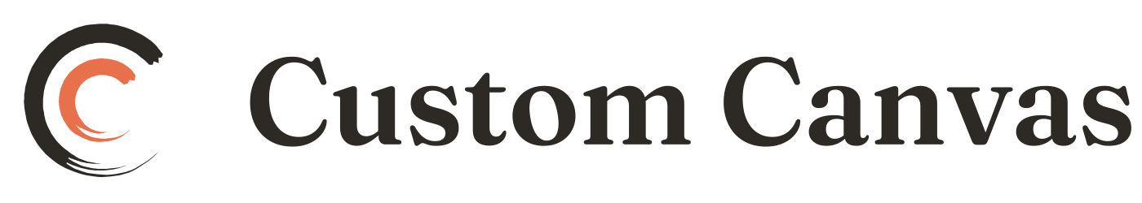
CUSTOM CANVAS
DMCA & Copyright Policy

STATUS | DRAFT. Ineffective until a designated agent is registered.
AUDIENCE | Everyone
VERSION | Draft v1.0
PREPARED | 25 August 2026
ENTITY | Custom Canvas LLC, a Texas limited liability company
Prepared for review by counsel. Not legal advice, and not prepared by a lawyer.
DRAFT — complete draft for counsel review.

⚠️ ACTION REQUIRED BEFORE LAUNCH. Custom Canvas hosts artwork uploaded by users and has no designated agent registered with the U.S. Copyright Office. Without a registered agent there is no §512(c) safe harbor, and an infringing upload becomes Custom Canvas's liability rather than only the uploader's. Registration is $6 through the Copyright Office's online directory (paper filings are no longer accepted) and must be renewed every three years or the safe harbor lapses. This policy is not effective until that registration exists.

Our position
Custom Canvas respects copyright. Artists warrant that they own or control the rights to everything they list. We remove material we are properly notified is infringing, and we terminate repeat infringers.

Reporting infringement
Send a written notice to our designated agent containing all of the following. An incomplete notice may not trigger our obligations.
- Your physical or electronic signature.
- Identification of the copyrighted work you say is infringed.
- Identification of the material on Custom Canvas you say infringes, with enough detail for us to find it — a direct URL to the listing or profile.
- Your name, address, telephone number and email.
- A statement that you believe in good faith that the use is not authorised by the copyright owner, its agent, or the law.
- A statement that the information in your notice is accurate, and under penalty of perjury, that you are the owner or authorised to act for the owner.

Designated agent [NAME / ROLE] Custom Canvas LLC 3120 Southwest Freeway, Ste 101 #991985, Houston TX 77098 [AGENT EMAIL]
These details must match, word for word, what is filed in the Copyright Office's online directory. A mismatch between the registered record and the published page is a common way for a safe-harbor defence to fail on a technicality. Whoever updates one updates the other.
Misuse warning. Knowingly misrepresenting that material is infringing can make you liable for damages, including costs and legal fees, under 17 U.S.C. §512(f).

What we do on receiving a notice
We remove or disable access to the material promptly, tell the artist what we removed and why, and give them a copy of the notice.

Counter-notice
If your work was removed and you believe that was a mistake or misidentification, send a counter-notice containing:
- Your physical or electronic signature.
- Identification of the removed material and where it appeared.
- A statement under penalty of perjury that you believe in good faith it was removed as a result of mistake or misidentification.
- Your name, address and telephone number, and a statement consenting to the jurisdiction of the federal court for your district (or, if outside the US, any district where we may be found), and that you will accept service from the person who gave the original notice.

If we receive a valid counter-notice we forward it to the complainant. Unless they tell us they have filed a court action, we may restore the material in 10 to 14 business days.

Repeat infringers
We terminate, in appropriate circumstances, the accounts of users who repeatedly infringe.
Our standard: three substantiated notices within twelve months results in termination of the account. A notice is not counted where the artist files a counter-notice that we accept, or where the notice is withdrawn or plainly defective. We may terminate immediately, without reaching three, for deliberate or large-scale infringement — wholesale copying of another artist's catalogue, for example.
[Counsel: a stated, consistently applied standard is what courts look for when assessing a repeat-infringer policy. Confirm the threshold and, more importantly, confirm we will actually apply it as written — an unapplied policy is worse than a lenient one.]

Not a substitute for the Listing Standards
A DMCA notice addresses copyright: who owns an image. Claims that a work is forged, misattributed or misdescribed address whether a piece is what it claims to be, and are handled under the Listing Standards. Different problem, different process.
Questions: support@customcanvas.shop

